Physics 30 Review of Physics 20 Essentials

Welcome to Physics 30. The Physics 30 course builds on a number of ideas and skills that you learned in Physics 20. Physics 30 requires that the following ideas and skills are well understood:

* manipulation of equations with ease (**Essential**)
* problem solving – proper selection of equations and identifying known and unknown quantities
* adding and calculating vectors
* understanding the dynamics of situations (i.e. application of Newton’s laws)
* uniform circular motion

# Examples

How fast will an object be travelling after falling for 7.0 s?

1 = 0

2 = ?

t = 7.0 s

 = -9.81 m/s2



****2 = **-69 m/s or 69 m/s down**

A man standing on the roof of a building throws a stone downward at 20 m/s and the stone hits the ground after 5.0 s. How tall is the building?

1 = -20 m/s

 = -9.81 m/s2

t = 5.0 s

d = ?



**d = – 2.2 x 102 m or 2.2 x 102 m down**

What are the components of a plane flying at 500 km/h at 60° N of W?

500 km/h

60°

vy

vx

vy = 500 km/h sin 60° = **433 km/h north**

vx = 500 km/h cos 60° = **250 km/h west**



A man walks 40 m at 30° N of E, then 70 m at 60° S of E, and finally 20 m at

45° N of W. What is the displacement of the man?

**Step 1.**

Our first task is to find the north, south, east and west components of all the vectors.

Vector 

The EAST component x = 40 cos 30° = 34.64 m (E)

x

y

40 m

30o

The NORTH component y = 40 sin 30 ° = 20 m (N)

Vector 

y

x

60o

70 m

the East component x = 70 cos 60° = 35 m (E)

the South component y = 70 sin 60° = 60.62 m (S)

Vector 

x

y

45o

20 m

the West component x = 20 cos 45° = 14.14 m (W)

the North component y = 20 sin 45° = 14.14 m (N)

**Step 2**

Find the north-south and east-west components of the resultant vector:

(N - S) = 20 m (N) + 60.62 m (S) + 14.14 m (N) = 26.48 m south

(E - W) = 34.64 m (E) + 35 m (E) + 14.14 m (W) = 55.5 m east

**Step 3**

Drawing a sketch of the two vectors we get:

the angle can be found

26.48 m

55.5 m

❑

 d

tan θ = opp = 55.5 m

adj 26.48 m

θ = 64.5° E of S

the displacement can be found by

 = 61.5 m

** = 61.5 m [64.5o E of S]**

An airplane flies North at 300 km/h but a wind is blowing west at 70 km/h

a) What is the velocity of the plane relative to the ground?

b) How far off course will the plane be after 3 hours?

70 km/h

a)

tan θ = opp/adj = 70 km/h / 300 km/h

θ = 13.13° W of N

pVg

300 km/h



❑

pVg = 308.15 km/h

→

**pVg = 308 km/h at 13° W of N**

b) the wind is the direct cause for the plane going off course.

d = v**1**t + ~~½ a t~~~~2~~ (no acceleration)

d = 70 km/h (W) x 3 hours = **210 km (W)**

A car traveling at 20 m/s goes around an unbanked curve in the road which has a radius of 122 m. What is the acceleration experienced by the car? What provided the centripetal force?

ac = v2 = (20 m/s)2 = **3.27 m/s2** (The force is provided by the friction between the tires

r 122 m and the road.)

A 1.8 kg object is swung from the end of a 0.50 m string in a horizontal circle. If the time of revolution is 1.2 s, what is the tension in the string?

The centripetal force (Fc) is the tension force (FT) in the string. Therefore



FT = **25 N**

A 2.0 kg object experiences a 15 N force pulling south, a 25 N force pulling west and a 20 N force pulling at 30° S of E. What is the acceleration experienced by the object?

**25 N •**

free body diagram

**30°**

**20 N**

**15 N**

Using the methods for adding vectors using components we first solve for the net force.

(N-S) = 15 N (S) + 10.0 N (S) = 25.0 N (S)

(E-W) = 25 N (W) + 17.32 N (E) = 7.68 N (W)

Ax = 20 cos30

Ax = 17.32 N (E)

Ay = 20 sin30

Ay = 10.0 N (S)

**30°**

A = 20 N

FNET



❑

Fnet = 26.16 N

25.0 N

tan  = 7.68 / 25

7.68 N

❑ = 17.1o W of S

Thus the acceleration becomes

 = = 26.16 N [17.1o W of S] =  **13.08 m/s2 [17.1° W of S]**

m 2.0 kg

What is the force required to accelerated a 50 kg object upward at 2.0 m/s2?

•

T (tension)

g (weight)

Acceleration upward implies an unbalanced (net) force acting upward.

Step 1 Step 3

g = m  = 50 kg(-9.81 m/s2) T + g = NET

g = -490 N T + (-490 N) = +100 N

T = **+590 N** or **590 N upward**

Step 2

NET = m = 50 kg(+2.0 m/s2)

NET = +100 N

A force of 90 N is applied to a wagon (mass 40 kg) at an angle of 30° to the horizontal. If the frictional force is 27.94 N, what is the resulting acceleration of the wagon?

90 N

FN

FA = 90 N

30**°**

•

Ff = 27.94 N

Fg

Unless the applied force is large enough to pull the wagon off the ground, only the horizontal component of the force will cause the wagon to accelerate.



90 N

NET = +77.94 N + (-27.94 N)

NET = 50.0 N east

30**°**

Fx = 90 N (cos 30)

Fx = 77.94 N

 = = 50.0 N (E) = **1.25 m/s2 east**

m 40 kg

A 10 kg box is dragged over a horizontal surface by a force of 40 N. If the box moves with a constant speed of 0.50 m/s, what is the coefficient of kinetic friction for the surface?

The velocity is constant. a =0 Fnet = 0 ∴ FA = Ff = 40 N

The surface is horizontal: ∴ FN = Fg = m g = 10 kg(9.81 m/s2) = 98.1 N

❍ = Ff = 40 N = **0.41**

FN 98.1 N

**Kinematics review**

1. State the displacement of each of the following changes in position
   1. -8 km to -2 km
   2. +2 km to -8 km
   3. 0 km to +8 km
   4. -8 km to +20 km
   5. +8 km to -8 km
2. An electron travels at a uniform speed of 1.3 x 105 m/s. How much time is required for the electron to move a distance of 1.0 m? (7.7 s)
3. A rally driver completes three consecutive sections of a straight rally course as follows: section 1 (10 km) in 7.50 min, section 2 (18 km) in 14.40 min, and section 3 (9.8 km) in 5.80 min. What was the average speed through the three sections? (1.4 km/min)
4. A car accelerates uniformly from 10 m/s to 30 m/s in 10 s. What is the acceleration? (2.0 m/s2)
5. A ball thrown straight up in the air has an initial velocity of 40 m/s and reaches its maximum height in 4.0 s. What was the acceleration of the ball? (-10 m/s2)
6. A ball is rolled up a slope with an initial speed of 6.0 m/s. The ball experiences an acceleration of 2.0 m/s2 down the slope. What is its velocity after (a) 2.0 s, (b) 3.0 s and (c) 4.0 s? (+2.0 m/s, 0, -2.0 m/s)
7. An electron is accelerated uniformly from rest to a speed of 2.0 x 107 m/s. If the electron travelled 0.10 m while it was being accelerated, what was its acceleration? How long did the electron take to reach its final speed? (2.0 x 1015 m/s2, 1.0 x 10-8 s)
8. A bullet is shot vertically into the air with an initial velocity of 500 m/s. Ignoring air resistance:
   1. How long does it take for the bullet to reach its maximum height? (51 s)
   2. How high does the bullet go? (1.3 x 104 m)
9. A balloon is ascending at the rate of 9.0 m/s and has reached a height of 80 m above the ground when the occupant releases a package. How long does the package take to hit the ground? (Hint: What is the initial velocity of the package relative to the ground?) (5.1 s)
10. A person drops a ball from a height of 20 m. What is the ball’s final velocity and how long does it take to fall? (-19.8 m/s, 2.0 s)
11. A stone is thrown upward with an initial velocity of 11 m/s. Calculate the maximum height and the time the stone is in the air. (2.2 s, 6.2 m)
12. A stone is thrown vertically upward from a 117.82 m high cliff with an initial velocity of 19.62 m/s. How long will it take for the stone to hit the water below? (7.29 s)
13. A stone is thrown horizontally at 19.62 m/s from a 117.82 m high cliff. How long will it take for the stone to hit the water below? How far from the base of the cliff will the stone land? (4.90 s, 96.2 m)

**Vectors review**

1. The gondola ski lift at Keystone, Colorado is 2830 m long. On average, the ski lift rises 14.6o above the horizontal. How high is the top of the ski lift relative to the base? (713 m)
2. A highway is planned between two towns in Saskatchewan, one of which lies 35.0 km south and 72.0 km west of the other. What is the shortest length of highway that can be built and what would be its bearing? (80.0 km @ 26o S of W)
3. Three ropes are attached to a heavy box on a frictionless surface. One rope applies a 475 N force due east and the other applies a 315 N force due south. What force must be applied to the other rope to cancel the other forces? (570 N @ 34o N of W)
4. A helicopter is travelling with a speed of 67.0 m/s @ 38.0o south of east. What are the south and east components of the helicopter’s velocity? (41.2 m/s south, 52.8 m/s east)
5. An airplane is being flown due east with respect to the air at 120 km/h. If a wind is blowing 70 km/h @ 30o south of east relative to the ground, what is the airplane’s velocity relative to the ground? (184 km/h @ 11o S of E)
6. A force vector of 45.0 N @ 30.0o north of east is added to an other force vector 75.0 N [N]. What is the resulting force? (105 N @ 22o E of N)
7. A pilot flies from point A to B to C in two straight line segments. The displacement vector for the first leg is 243 km @ 50.0o N of E and the second leg displacement vector is 57.0 km @ 20.0o S of E. What is the resultant displacement vector? (268 km @ 38o N of E)

**Circular motion review**

1. A 1.0 kg ball at the end of a 2.8 m rope rotates once every 0.98 s.
   1. What is the speed of the ball? (18 m/s)
   2. What is the tension in the rope? (1.2 x 102 N)
2. A car with a mass of 822 kg rounds an unbanked curve in the road at a speed of 28.0 m/s. If the radius of the curve is 105 m, what is the minimum frictional force required to keep the car on the road? (6.14 x 103 N)
3. A 1.7 kg object is swung from the end of a 0.60 m string in a horizontal circle. If the time of one revolution is 1.1 s, what is the tension in the string? (33 N)

**Dynamics review**

1. A car is at rest on a horizontal road surface. The driver presses down on the gas pedal and the car accelerates forward for a few seconds until it reaches the speed limit. The driver eases off of the gas pedal and the car moves at constant speed. Describe and explain the car’s motion in terms of Newton’s three laws.
2. A net force of 30.0 N south acts on a 10.0 kg object. What is the acceleration of the object? (3.00 m/s2 south)
3. A 22 kg object accelerates uniformly from rest to a velocity of 2.5 m/s west in 8.7 s. What is the net force acting on the car during the acceleration? (-6.3 N)
4. What is the acceleration due to gravity near the surface of the moon if an object has a weight of 36.0 N and a mass of 22.0 kg? (1.64 m/s2)
5. An object with a mass of 45.0 kg is pulled along a horizontal surface by a rope that makes an angle of 32.0o with the horizontal. If the frictional force is 50.0 N and the tension in the rope is 95.0 N, what is the acceleration of the object? (0.679 m/s2)
6. An object with a mass of 25 kg is pulled across a floor at constant speed with a pulling force of 68 N. What is the coefficient of friction on the floor surface? (0.28)
7. 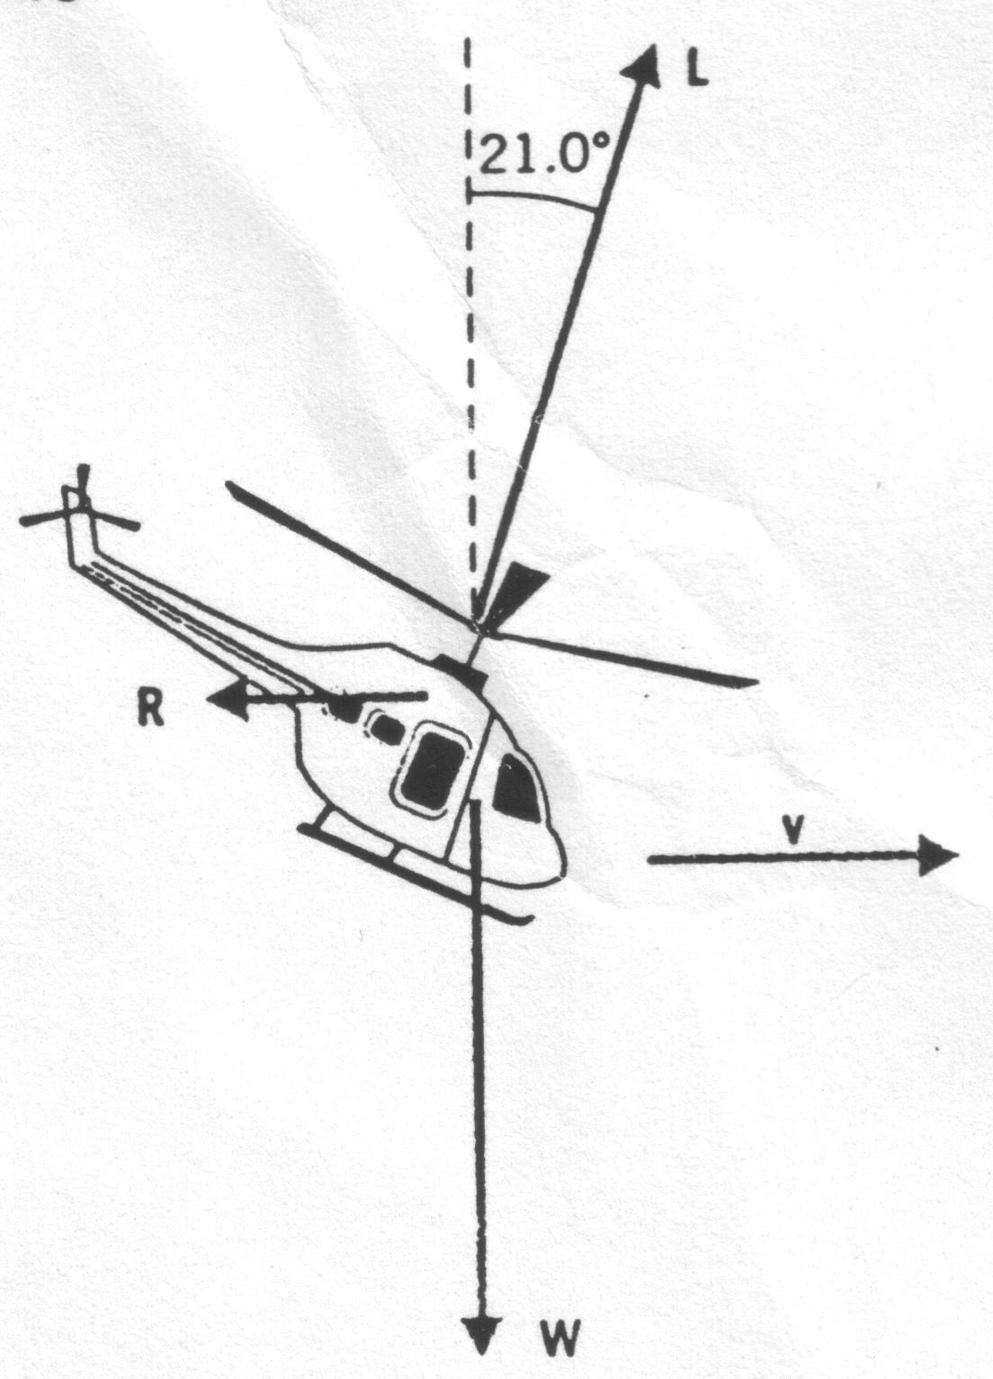What is the tension in the cable of a 1.20 x 103 kg elevator that is
   1. accelerating downward at 1.05 m/s2? (1.05 x 104 N)
   2. accelerating upward at 1.05 m/s2? (1.30 x 104 N)
   3. moving downward at 1.05 m/s? (1.18 x 104 N)
8. The helicopter in the drawing to the right is moving horizontally with a constant velocity. The weight of the helicopter is 5.38 x 104 N and the lift force **L** generated by the rotating blade makes an angle of 21.0o with respect to the vertical.
   1. What is the magnitude of the lift force? (5.76 x 104 N)
   2. What is the air resistance **R** that opposes the motion? (-2.07 x 104 N)
9. A supertanker (mass = 1.50 x 108 kg) is being towed by two tugboats as shown in the diagram. The tensions in the towing cables apply the force **T1** and **T2** at equal angles of 30.0o with respect to the tanker’s axis. In addition, the tanker’s engines produce a forward driving force **D** of 7.50 x 104 N and the water applies an opposing force **R** of 4.00 x 104 N. The tanker moves forward with an acceleration of 2.00 x 10-3 m/s2. Find the tensions in the towing cables. (1.53 x 105 N)

